Exploring how climate will impact plant-insect distributions
and interactions using open data and informatics

SP-1: Natural History of Butterfly-Host Plant Interaction
- Assignment -

- Example -

Student Name

Butterfly Species: Giant swallowtail, Papilio cresphontes
Family: Papilionidae
Order or Suborder: Lepidoptera

Image of Butterfly:
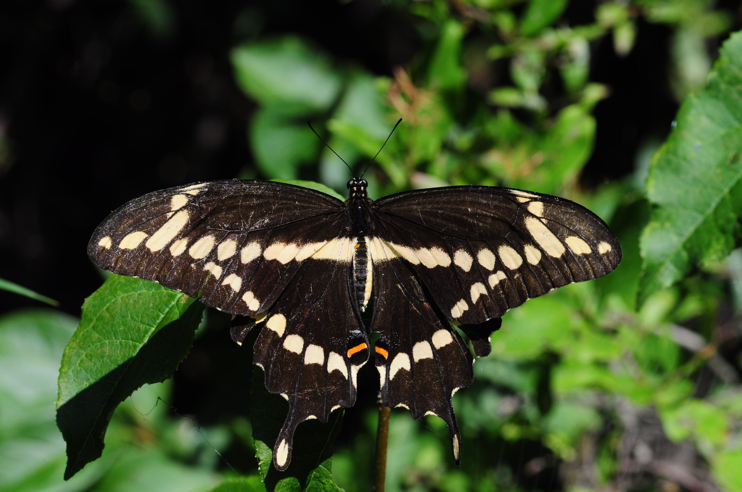

Photographed on August 12, 2011 Pointe Petre, Ontario Canada Photo credit: M Larrivee

Physical appearance: Upper-side of adult butterfly is a brownish black with large, yellow diagonal spots. Tails are yellow edged in black. Larvae are light brown or black with a highly reflective white spotting to resemble bird droppings. When disturbed, larvae will display the conspicuously colored osmeteria emitting a foul odor to further deter predation.

Foraging behavior as larvae and adult: Eats herbs and trees in the citrus family (Rutaceae) as a larva, then consumes a wide variety of nectar as an adult butterfly, males often found mud puddling on damp soil to acquire nutrients for mating.

Habitat: Often found in suburban and urban areas, citrus groves, or riparian areas

Range: Eastern North America to Rock Mountains

Larval Host Plants: Common North American larval host plants include prickly ash (Zanthoxylum americanum), hop tree (Ptelea trifoliata), and common rue (Ruta graveolens).

Most Frequent Host Plant Reported on iNaturalist: prickly ash (Zanthoxylum americanum)

Unusual Ecological Interactions: This butterfly species uses multimodal signaling (visual and olfactory) to deter predators as larvae

